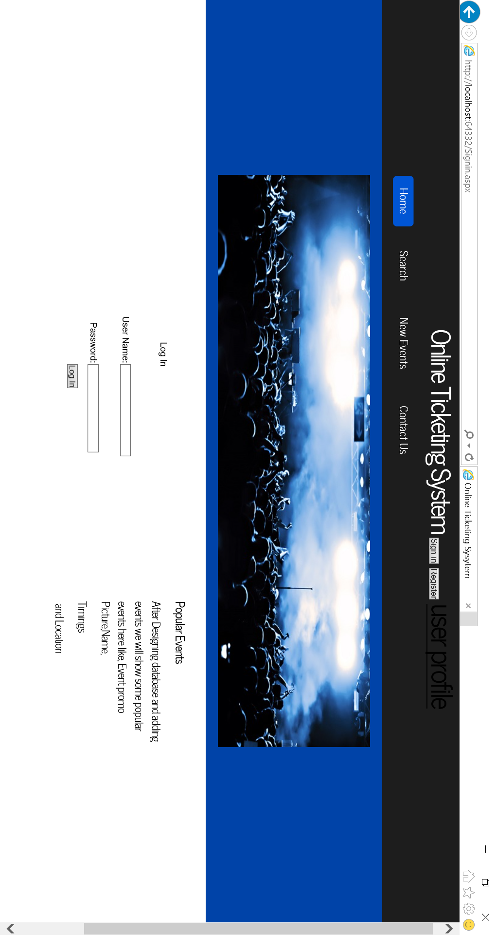

This Page is Used to login into the system by the user or admin

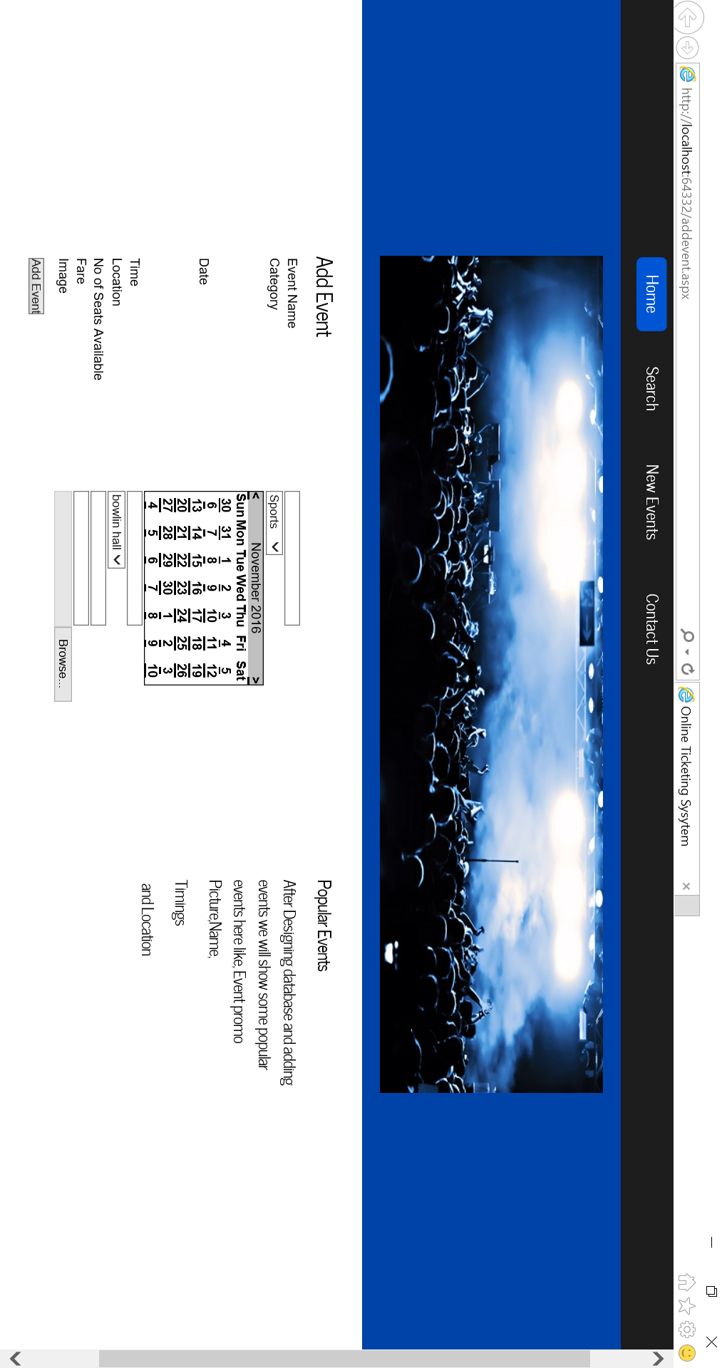

This Page is for adding the new event for the admin

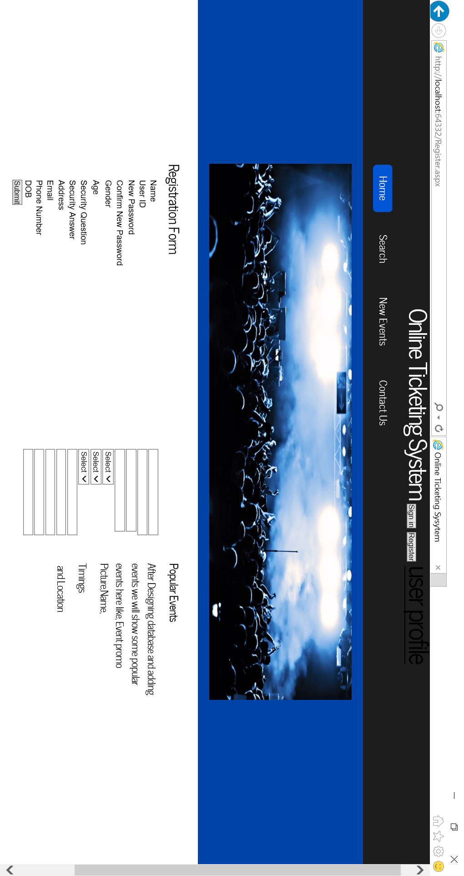

This is a registration form to register a user account in the system.

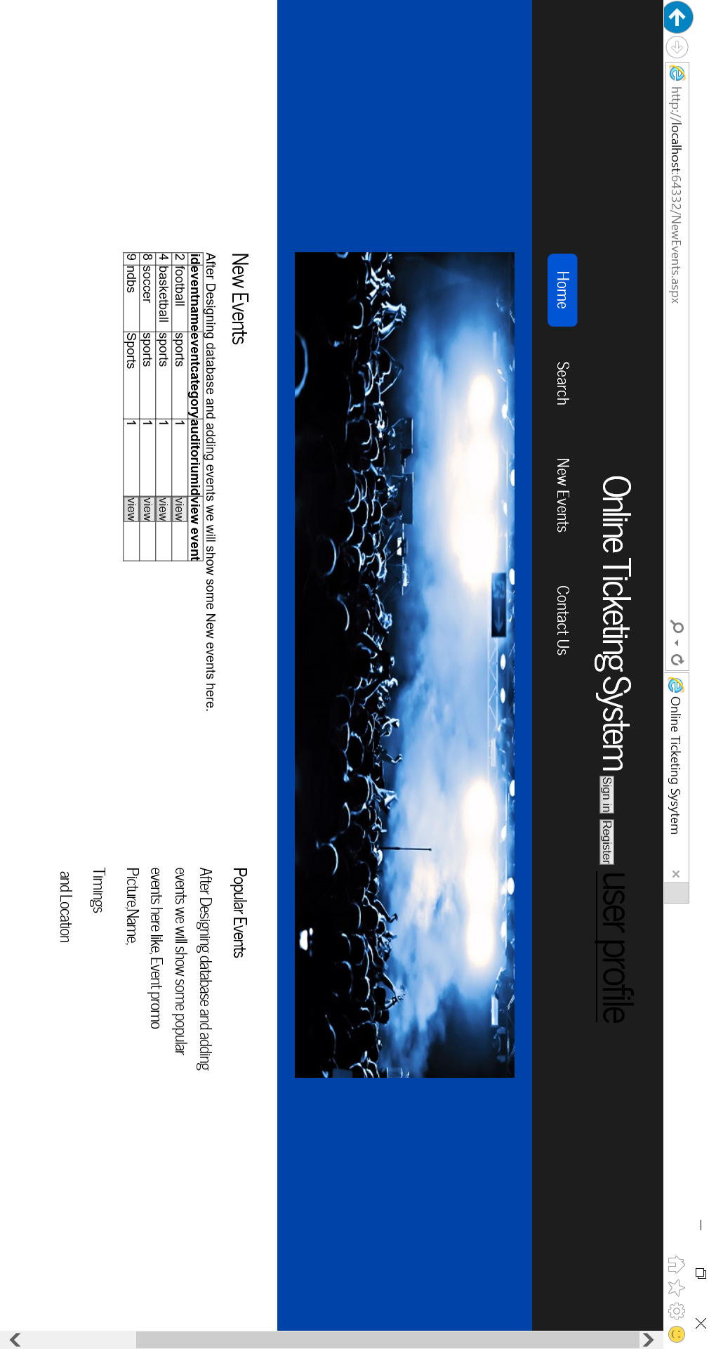

This page is for to show new events in the system.

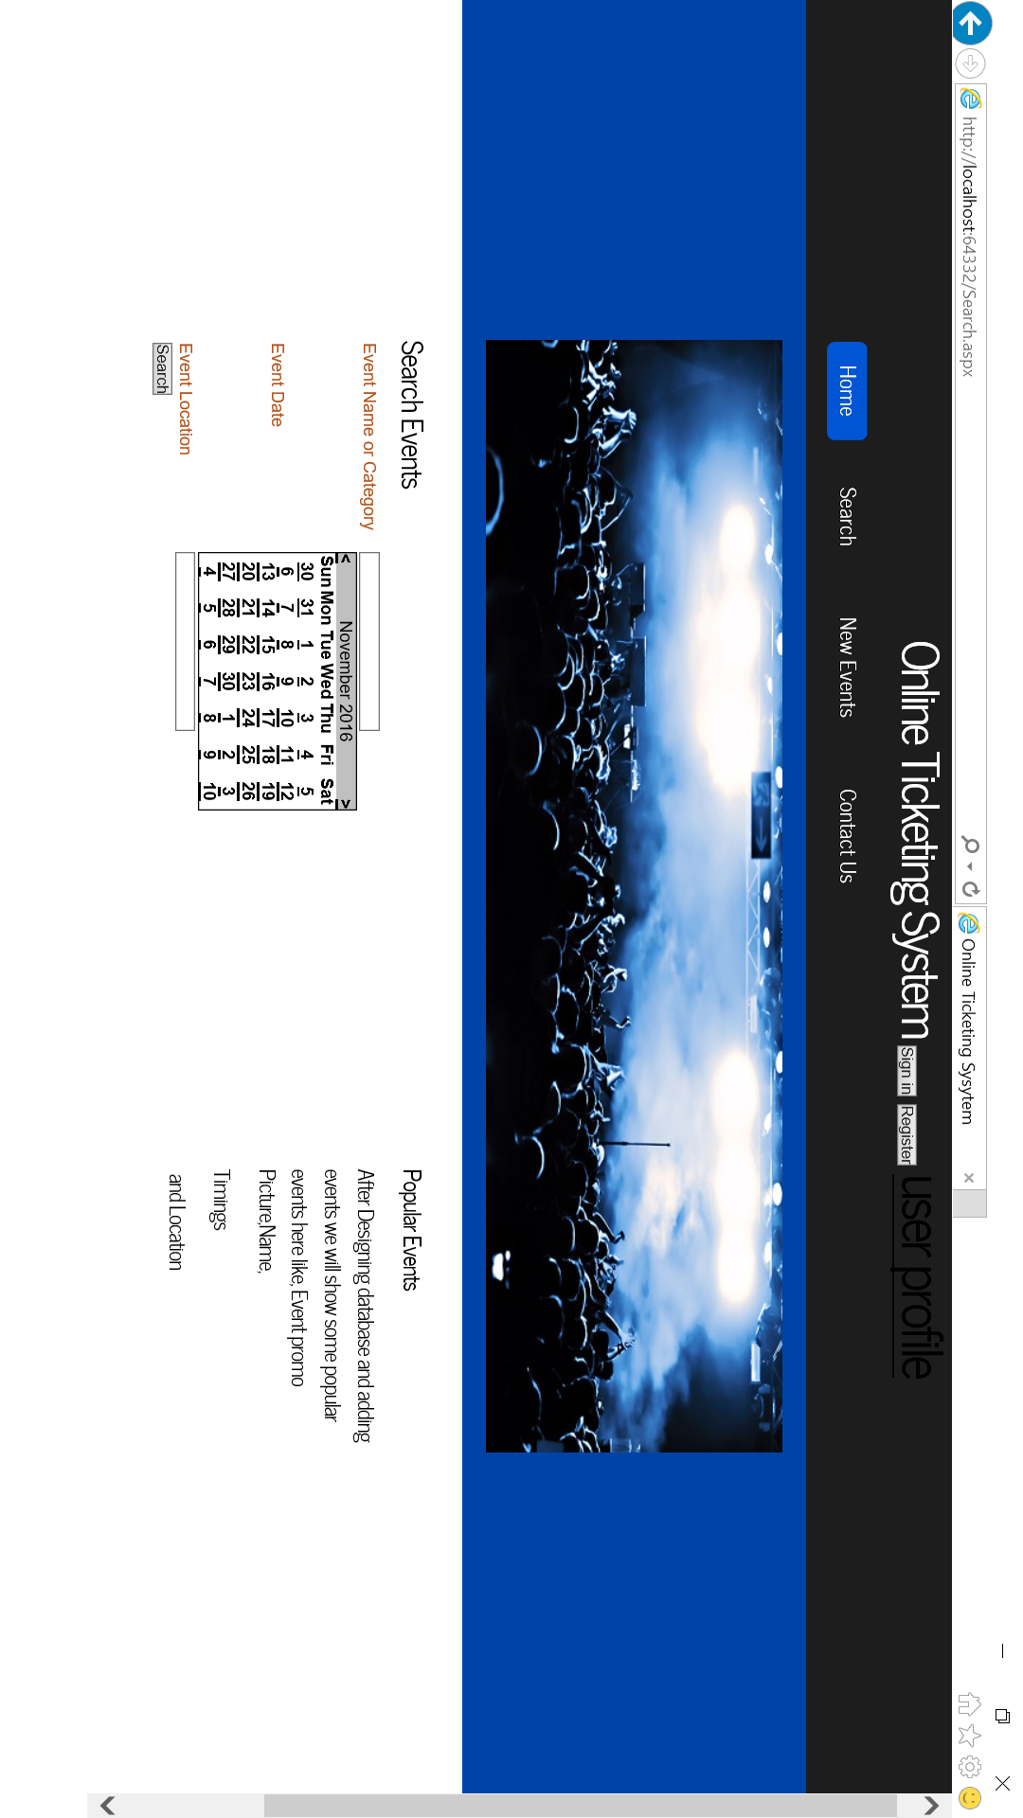

This page is used to search events in the system either by using event name, category, event date or location.

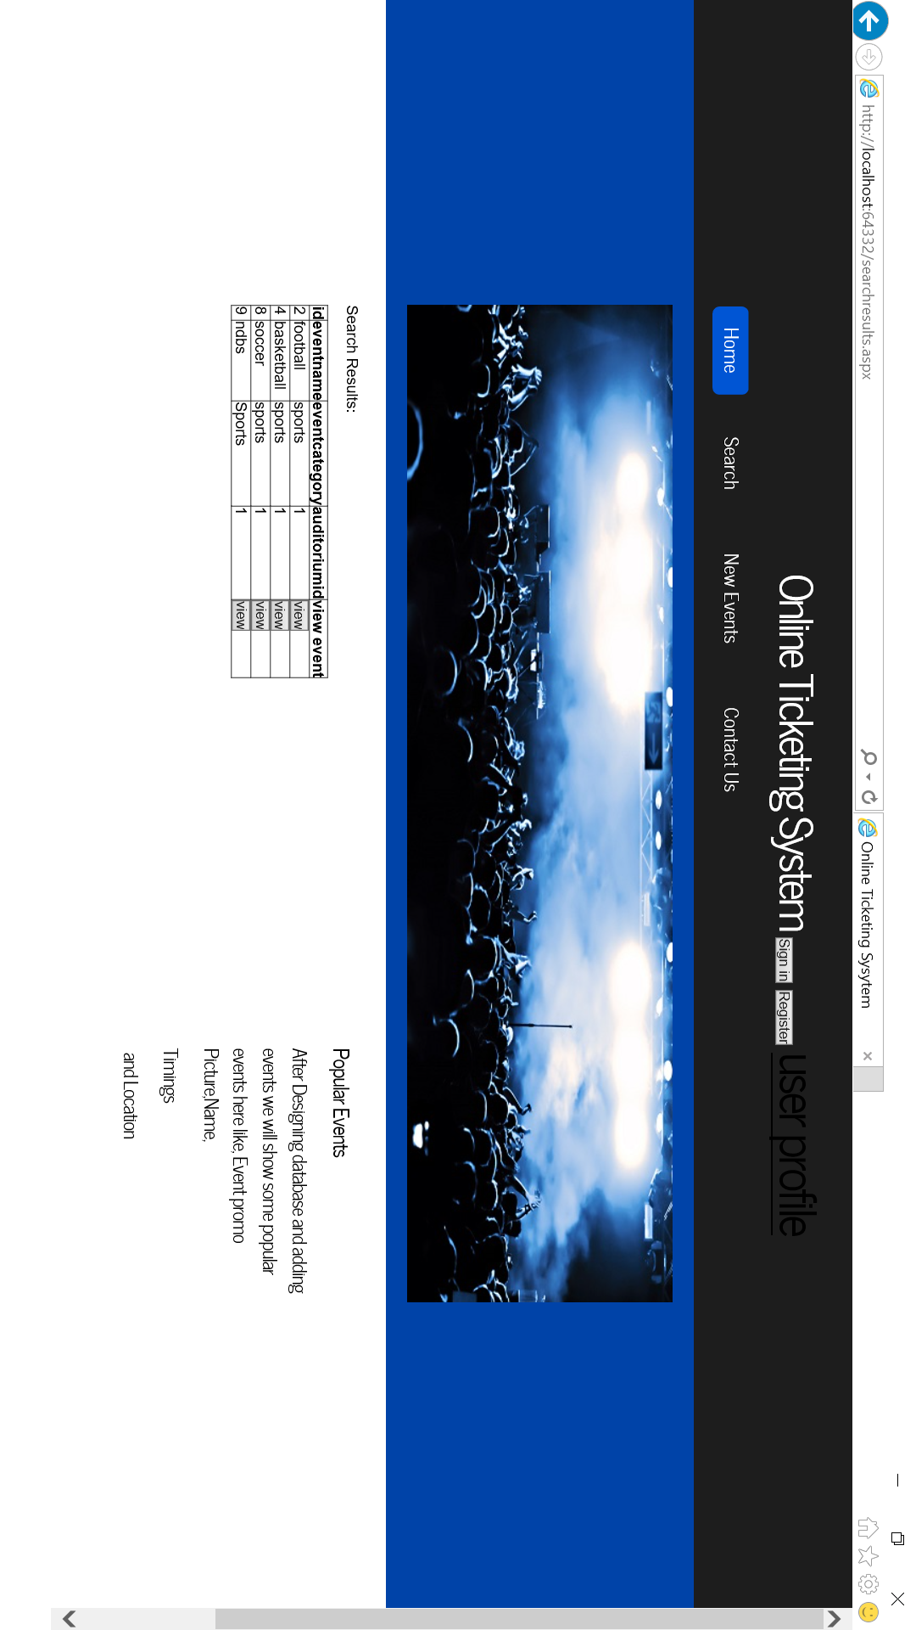

This page is used to show the search results.

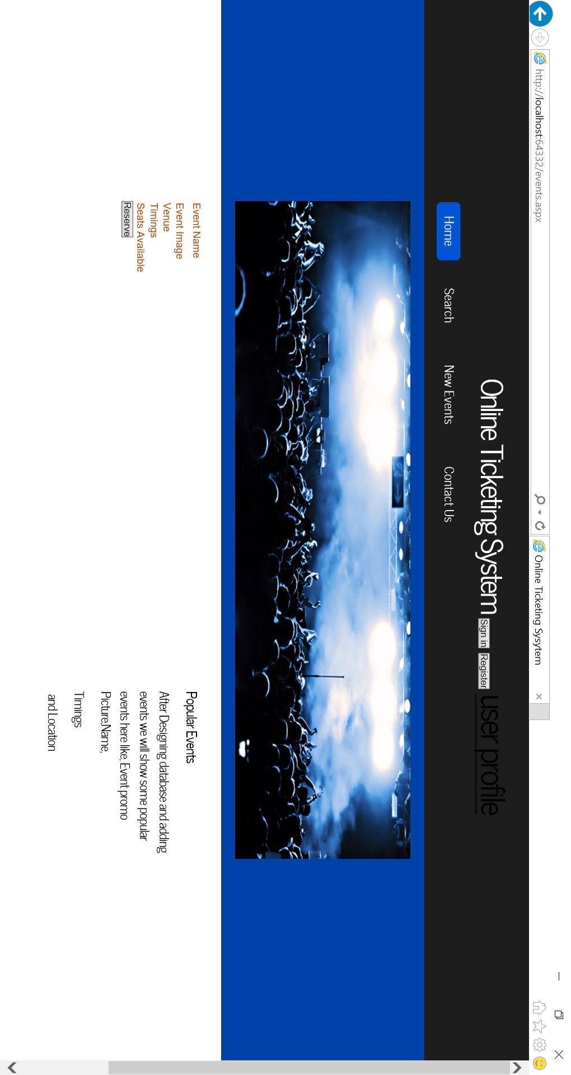

This page is used to show the event date when the user hits view button in the search results.

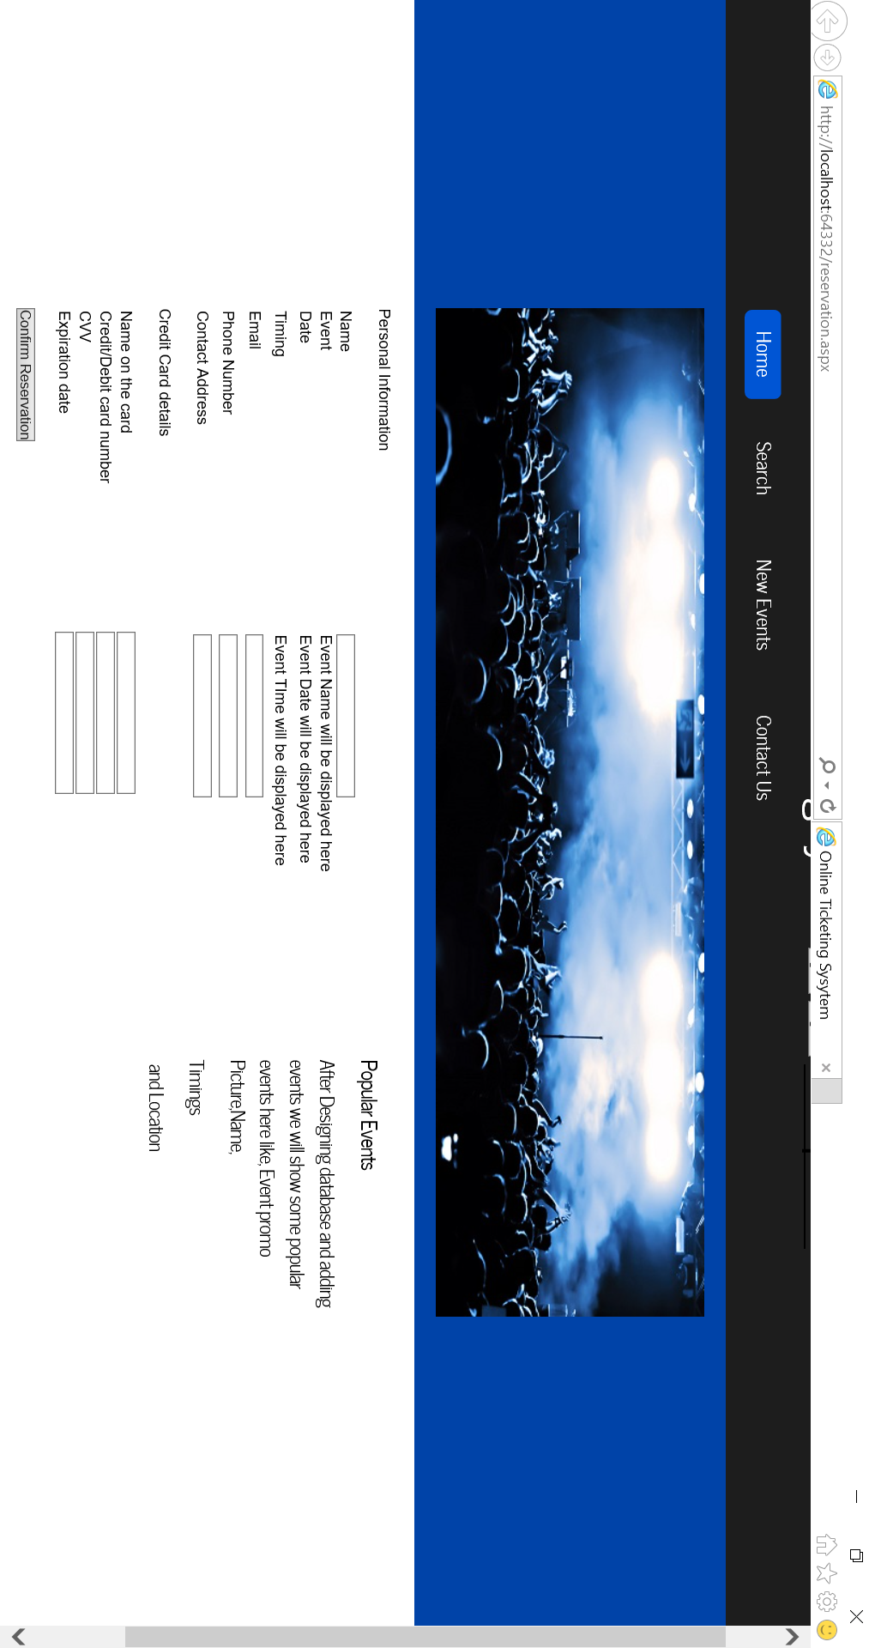

This page is used to reserve tickets for an event. user enters his information in this page to reserve tickets.

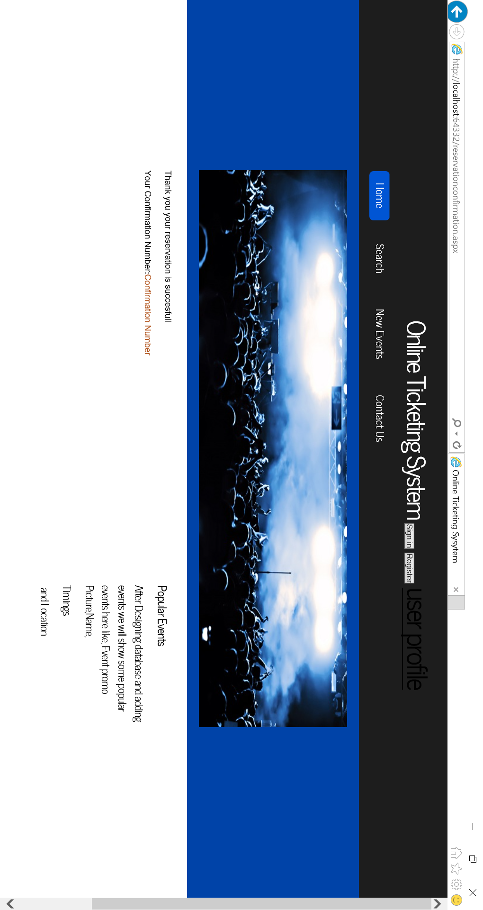

This is the confirmation page for the reservation. User is provided with confirmation number.

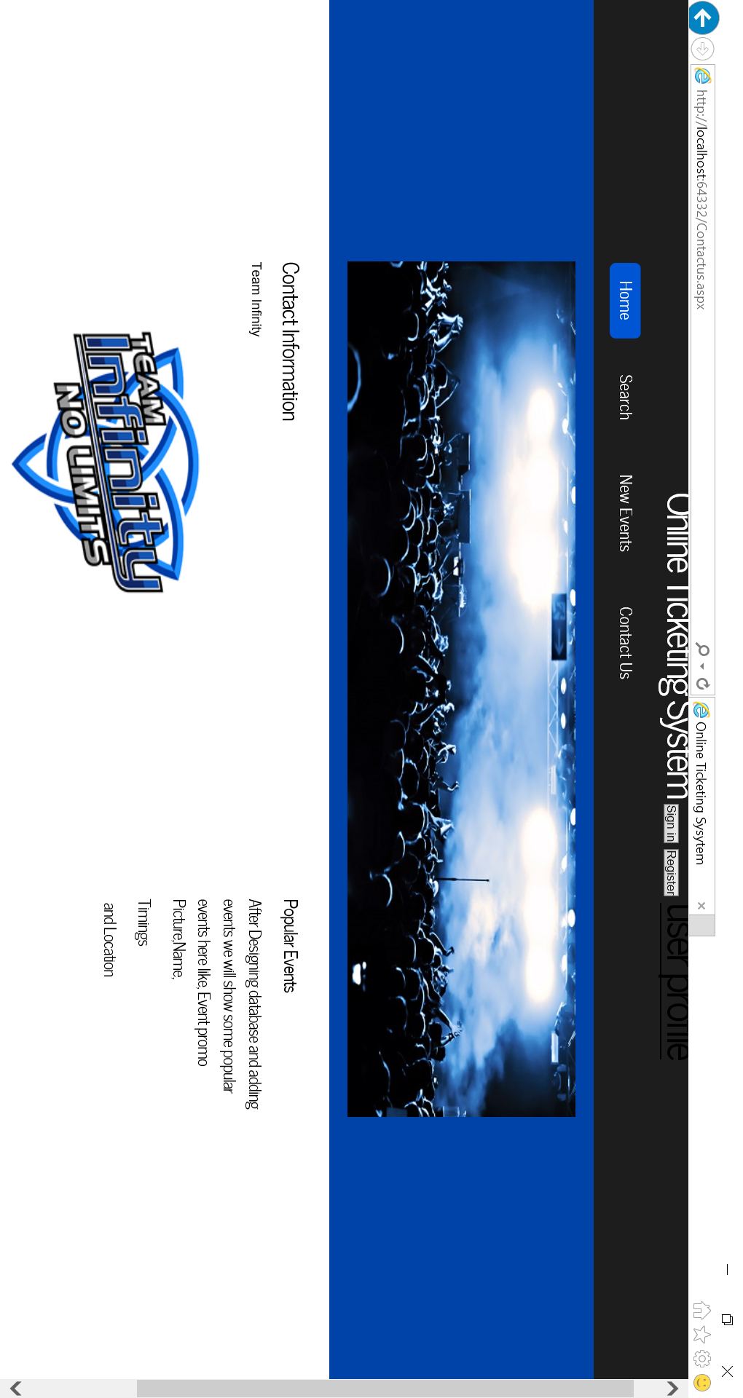

This page is useful for displaying the custom service information and management details.